Cumulative Time (Years) | Delta Time (years) | Slip (cm) or Magnitude
1 | 1 | 1.4
6 | 5 | 6.9
14 | 8 | 12.6
17 | 3 | 3
21 | 4 | 4.3
26 | 5 | 6.9
29 | 3 | 1.4
30 | 1 | 1.1
32 | 2 | 1.8
34 | 2 | 1.5
36 | 2 | 1.5
39 | 3 | 3.6
42 | 3 | 0.7
44 | 2 | 1.7
45 | 1 | 1.9
48 | 3 | 4.1
49 | 1 | 1.8
51 | 2 | 1
52 | 1 | 2.7
53 | 1 | 0.8
57 | 4 | 5.3
59 | 2 | 2.1
62 | 3 | 2
67 | 5 | 6
70 | 3 | 4.3
72 | 2 | 1.6
78 | 6 | 8
83 | 5 | 7.3
85 | 2 | 2.7
89 | 4 | 1.7
90 | 1 | 0.7
91 | 1 | 2.6
93 | 2 | 1.3
109 | 16 | 27.8
111 | 2 | 2.8
112 | 1 | 0.7
114 | 2 | 2.6
117 | 3 | 3.1
120 | 3 | 2.1
133 | 13 | 3.6
137 | 4 | 5.1
140 | 3 | 2.5
144 | 4 | 3.2
149 | 5 | 5.7
154 | 5 | 4.4
159 | 5 | 7
161 | 2 | 1.2
163 | 2 | 1.6
Slip (cm) | (N) | Log N
1
3
5
7
9
Examining the Frequency-Magnitude Relationship

The Gutenberg-Richter relationship describes the relationship between the average reoccurrence rate of earthquake equal to or greater than a given magnitude.

N is the number of earthquakes having a magnitude ≥ magnitude M. Constants a and b are constants related to the stresses experienced by a body of rock. Constant a indicates the total seismicity rate of the region and constant b is generally calculated (and usually ~1).
The Earthquake Machine

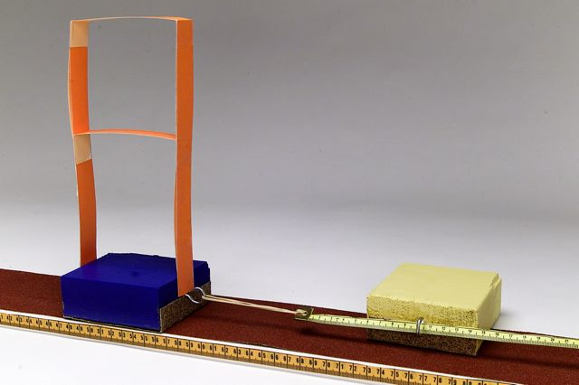

Seismic Moment (M_{o}) = A x D x μ or Area x Displacement (Slip) x Rigidity

Moment Magnitude (M_{w}) = 2/3log M_{o} – 10.7

